**Project Title: GeoVi**

**Team Members: Anna Kutova**

1. Project Card 3

Project Description: 3

Implementation Plan: 3

Why this idea? 3

2. Stakeholders of the GeoVi Project 4

Primary Users (Students, Educators, and Geography Enthusiasts): 4

App Developers and Designers: 4

Educational Institutions: 4

App Store (Apple's iOS/macOS Ecosystem): 4

End Users’ Families: 4

Geography Education Researchers: 5

Society at Large: 5

3. Project Management Method: Agile 6

Why Agile is Suitable: 6

Employees' Functions and Relationships 6

**Roles:** 6

**Relationships:** 7

4. Requirement Gathering and Analysis 8

Purpose and Scope of Requirement Gathering 8

Key Stakeholders and Their Roles 8

Requirement Gathering Process (aligned with SDLC) 8

Potential Issues and Risks 10

5. System Design and Testing 11

System Architecture 11

Database Structure 11

Diagrams 11

Test Plan 13

Test Scenarios 13

# **Project Card**

## **Project Description:**

GeoVi is an interactive geography learning application designed for iOS and macOS.

The app features a widget that displays a country’s flag, its location on the map and name.

GeoVi aims to make geography more engaging by providing users with quick and easy access to key information about different countries through a user-friendly interface.

## **Implementation Plan:**

The team plans to fully develop GeoVi, with future updates introducing advanced features, such as continent-specific filtering or other customizable criteria.

The project is intended for release as an educational tool, optimized for iOS and macOS devices.

## **Why this idea?**

GeoVi was conceptualized to simplify geography learning for individuals who may find memorizing facts tedious.

The project seeks to enable effortless learning by delivering geographical information directly to users through widgets, eliminating the need for active app engagement.

# **Stakeholders of the GeoVi Project**

## **Primary Users (Students, Educators, and Geography Enthusiasts):**

These are individuals who directly interact with the application. Students can use GeoVi as a supplementary tool for learning geography, while educators may integrate it into their teaching process. Geography enthusiasts will benefit from the ease of access to key geographical information.

## **App Developers and Designers:**

The development team focuses on creating a user-friendly and functional application. Success is tied to ensuring the app’s usability and adaptability to user feedback.

## **Educational Institutions:**

Schools, universities, and other educational organizations might adopt GeoVi as a learning tool. Their relationship to the project involves using it to enhance their geography curricula.

## **App Store (Apple's iOS/macOS Ecosystem):**

GeoVi will rely on the App Store for distribution, making Apple an indirect stakeholder. The app’s presence within this ecosystem affects the reach and visibility of the project.

## **End Users’ Families:**

The families of students and users may benefit indirectly from GeoVi if their relatives become more knowledgeable about geography. However, they may also be concerned about potential over-reliance on screen time for educational purposes.

## **Geography Education Researchers:**

Researchers in education and geography may study GeoVi’s impact on learning processes, analyzing its effectiveness as a digital educational tool.

## **Society at Large:**

As GeoVi promotes general geographical knowledge, the project indirectly benefits society by fostering a more educated and aware population. This has long-term positive social impacts.

***Relationship Specifics:***

*- The key relationship is between the primary users and developers, as continuous user feedback will shape future iterations of the app.*

*- Educational institutions may influence development by suggesting features to align GeoVi with specific curricula.*

*- The App Store influences app visibility and success, which affects distribution and accessibility.*

# **Project Management Method: Agile**

The Agile methodology has been adopted to support flexibility and continuous improvement throughout GeoVi’s development.

## **Why Agile is Suitable:**

**Flexibility**: Agile allows us to adapt to changes quickly, ensuring that the project stays relevant and meets user needs.

**Incremental Progress**: We can break the project into smaller, manageable tasks, which helps in tracking progress and delivering functional parts of the application regularly.

**Continuous Feedback**: Regular feedback cycles allow us to improve and refine the product based on user input and testing results.

**Collaboration**: Agile encourages team collaboration and communication, ensuring all members are involved in decision-making and problem-solving.

## **Employees' Functions and Relationships**

### **Roles:**

**Project Manager (PM)** – Oversees the entire project, manages the Agile process, and ensures that the team stays on track with the project goals.

**Developers** – Responsible for coding, implementing features, and fixing bugs. Work closely with the PM and each other to ensure smooth progress.

**UX/UI Designer** – Designs the user interface and experience, ensuring the application is intuitive and visually appealing.

**Quality Assurance (QA) Tester** – Tests the application at each stage of development, providing feedback on issues and suggesting improvements.

**Product Owner** – Represents the end-users' interests, prioritizes tasks, and ensures that the features being developed align with the project’s goals.

### **Relationships:**

|  |  |  |
| --- | --- | --- |
| **Project Manager** | The PM communicates regularly with the Product Owner to ensure that the project meets the user's needs and expectations. | **Product Owner** |
| The PM provides developers with clear goals and timelines, ensuring they understand the priorities. | **Developers** |
| **UX/UI Designer** | Developers work closely with the UX/UI Designer to implement the designs accurately and ensure a smooth user experience |
| **QA Tester** | QA Testers and developers collaborate to identify and fix bugs, ensuring that the application is functional and of high quality. |
| The PM reviews testing results with the QA Tester to prioritize issues that need immediate attention. | **Project Manager** |

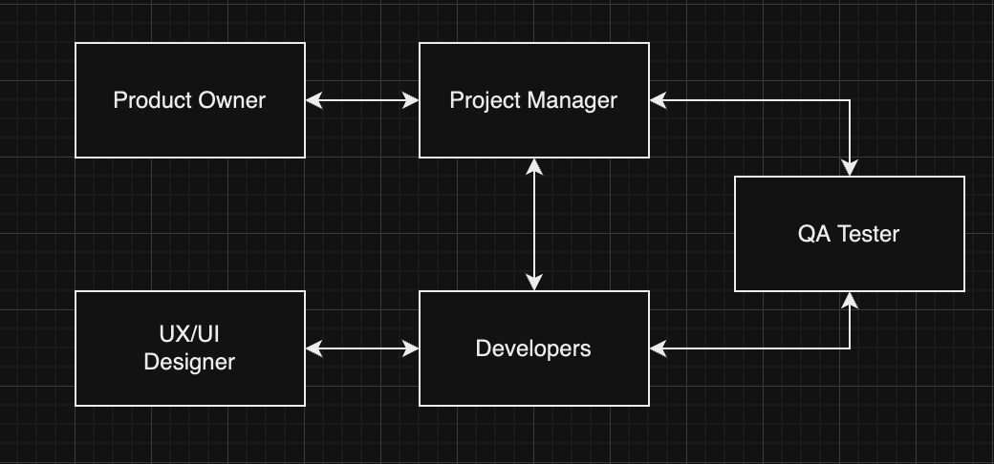

1. **Requirement Gathering and Analysis**

## **Purpose and Scope of Requirement Gathering**

* **Purpose**: To identify, analyze, and document the requirements for GeoVi to ensure it meets the needs of its target users, including students, educators, and geography enthusiasts.
* **Scope**: Focus on gathering functional requirements related to displaying a country’s flag, name, and location on a map, as well as ensuring that the interface is intuitive and suitable for educational purposes. Additionally, account for scalability to enable future enhancements, such as continent-based filtering or additional educational features.

## **Key Stakeholders and Their Roles**

* **Project Manager (PM)**: Oversees the requirement-gathering process, ensures requirements align with project goals, and manages communication between stakeholders.
* **Product Owner (PO)**: Represents end-user interests, prioritizes features based on educational value, and ensures the project aligns with user expectations.
* **UX/UI Designer**: Responsible for designing an interface that is both visually appealing and user-friendly, incorporating feedback from users.
* **Developers**: Implement requirements into functional code, ensure features are built as specified, and participate in requirement validation to clarify technical feasibility.
* **QA Tester**: Validates that each requirement is met and ensures the app is functioning as expected through continuous testing.

## **Requirement Gathering Process (aligned with SDLC)**

**Step 1: Requirement Elicitation**:

* + **Activities**: Conduct interviews with potential users (students and educators) to understand their needs and preferences. Review similar educational apps for best practices.
  + **Responsible**: Product Owner and Project Manager.
  + **Potential Challenges**: Limited access to users for feedback, difficulty in articulating requirements clearly by non-technical users.

**Step 2: Requirement Analysis**:

* + **Activities**: Analyze gathered data to identify essential vs. optional features. Define clear, measurable requirements, such as “display flag, name, and location for each country.”
  + **Responsible**: Product Owner, Developers, and UX/UI Designer.
  + **Potential Challenges**: Ambiguity in user feedback, technical constraints for certain features (e.g., interactive maps).

**Step 3: Requirement Specification**:

* + **Activities**: Document all requirements in a structured format, such as a Software Requirement Specification (SRS). This document should detail functional and non-functional requirements, user interface expectations, and scalability considerations.
  + **Responsible**: Project Manager and Product Owner.
  + **Potential Challenges**: Ensuring all requirements are complete and unambiguous, making sure stakeholders review and approve requirements.

**Step 4: Requirement Validation**:

* + **Activities**: Review and validate the requirements with stakeholders to confirm they align with project goals. Conduct mock-up sessions to visualize key features for feedback.
  + **Responsible**: Project Manager, Product Owner, Developers, and QA Tester.
  + **Potential Challenges**: Changes requested late in the process, difficulty getting timely feedback from all stakeholders.

## **Potential Issues and Risks**

* **Changing Requirements**: As GeoVi is an educational tool, new requirements may arise based on user feedback, potentially leading to scope creep.
* **Technical Constraints**: Implementing interactive map features could be technically challenging, requiring careful prioritization of features to ensure feasibility.
* **User Feedback Integration**: Balancing conflicting feedback from different user groups (e.g., students vs. educators) may complicate the design and feature set.

1. **System Design and Testing**

**System Architecture**

**Architecture Style**: Client-server

* + **Client**: iOS/macOS app displaying country details through widgets.
  + **Server**: Backend service for data storage, updates, and future feature scalability.

**Components**:

* + **Frontend**: Swift-based app.
  + **Backend**: RESTful API, Node.js/Express.
  + **Database**: Cloud-based (e.g., Firebase/Firestore for real-time sync).

**Database Structure**

**Type**: NoSQL (Firebase/Firestore)

**Key Collections**:

* + countries:
    - Fields: flag, name, location, continent.
  + users (future use):
    - Fields: preferences, progress.

**Diagrams**

**Data Flow Diagram**:

**Component Diagram**:

**Test Plan**

To ensure GeoVi operates smoothly across all use cases, the following test strategies are proposed:

1. **Unit Tests:**
   * Validate the logic for displaying country details (flag, name, location).
   * Check functionality for continent-based filtering.
2. **Integration Tests:**
   * Test communication between the client and server.
   * Verify data synchronization between the app and the database.
3. **System Tests:**
   * Evaluate performance on various devices (e.g., iPhone, MacBook).
   * Test widget updates and their refresh intervals.

**Test Scenarios**

* **Data Sets**:
  + Valid: Country details exist for all regions.
  + Invalid: Missing or incomplete data.
* **Error Testing**:
  + User errors: Inputting invalid criteria (e.g., unknown continent).
  + System errors: Network failures, server timeouts.